Title/Summary:’

Internet banking end to end

User’s requirements document

1. Background

Internet Banking System refers to systems that enable bank customers to Access accounts and general Information on bank products and services through a personal computer or other intelligent device.

The chances and threats that the internet symbolizes is no longer news to the present day banking sector. No traditional bank would dare face investment analysts without an Internet strategy. The main intention behind the commencement of electronic banking services is to provide the customers with an alternative that is more responsive and with less expensive options. With options just a click away, customers have more control than ever. Their expectations are usability and real-time answers. They also want personal attention and highly customized products and services.

* 1. Scope of the study

The scope of this project is limited to the activities of the operations unit of the banking system which includes opening of Account, Deposit of funds, Electronic funds transfer, Cheque balance and Monthly statement. In the figure below, is the use-case diagram of the Internet banking system that the customer can expect all those functions with the bank manager acceptance.

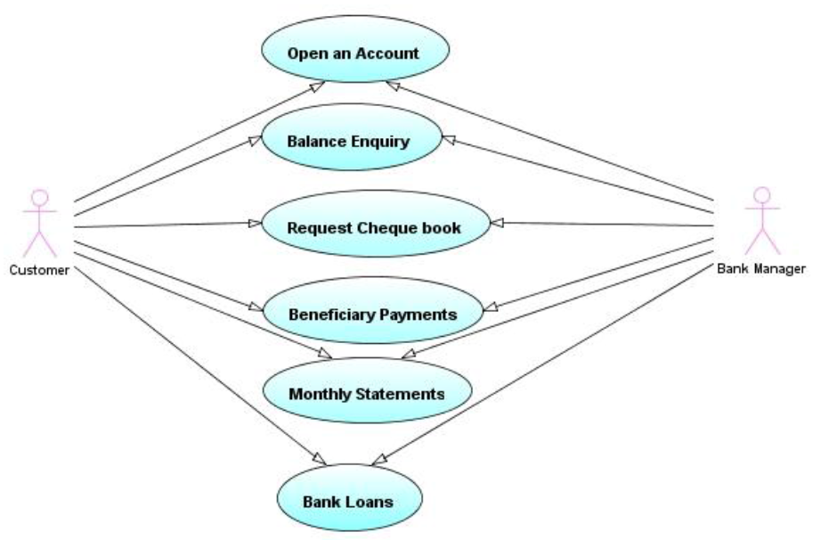

* 1. Limitations of the internet banking system

**Problems of security:** Various sites are not properly locked at to ensure whether the customer’s money is safe in cyber world or not.

**Wrong assumption:** Many people are afraid using Internet Banking because of the assumption that it is more expensive than the traditional method of dealing with bank transactions. They still prefer going to bank to perform transactions**.**

**Requirements Analysis Document**

2.1 Functional requirement

* Customer can request details of the last ‘n’ number of transactions he has performed on any account.
* Customer can make a funds transfer to another account in the same bank.
* Customer can view his monthly statement.
* The system is providing balance enquiry facility.

2.2 Class diagram

* The below class diagram shows that the customer can have more than one account and that relationship goes to one - many relationship.
* The transaction functions always depends on the web service, which means it’s a web based.

2.3 System Requirements

|  |  |
| --- | --- |
| Software Requirements | Hardware Requirements |
| Operating system: windows | Processor : any |
| Interface: HTML ,CSS | Hard Disk: 10Gb minimum |
| Database: MYSQL | RAM: 256MB or more |
| Programming Language: PHP |  |

**User Interface Specification**

The purpose of this document is to provide a detailed specification of the Internet Banking System user interface. These requirements will detail the outwardly observable behavior of the program. The user interface provides the means for the user, to interact with the program. This User Interface Specification is intended to convey the general idea for the user interface design and the operational concept for the software. This document will be updated with additional detail as our analysis and design activities progress.

3.1 Description of the complete user interface

* The User Interface Specification (UIS) consists of one main graphical user interface (GUI), which consists with different operations enlisted in the options.

3.2 What the user interface looks like

* The log in page consists of three text boxes, namely user ID, password, Language and a sign in command button allowing the customer to log into the system.
* The login page helps the user to login as a user who visualizes and analyze data contained in the database

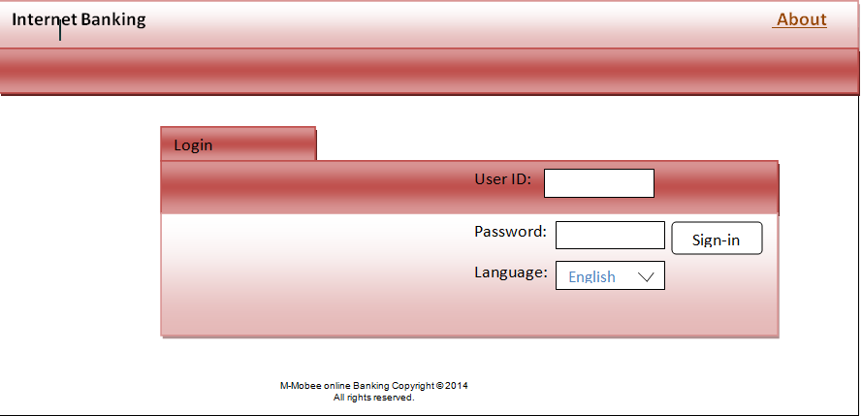

3.3 How the user Interface Behaves

* The system verifies users input in the field of user ID and password, and displays an error message if the customer enters incorrect information. Thus, if the customer provides an appropriate data, then he will be allowed to log in
* Once logged on, the user is ready to perform the following,

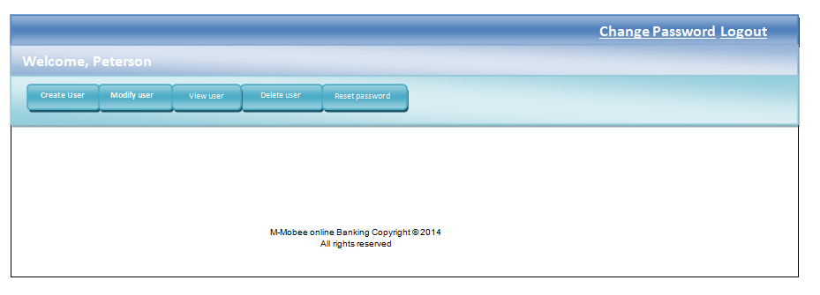

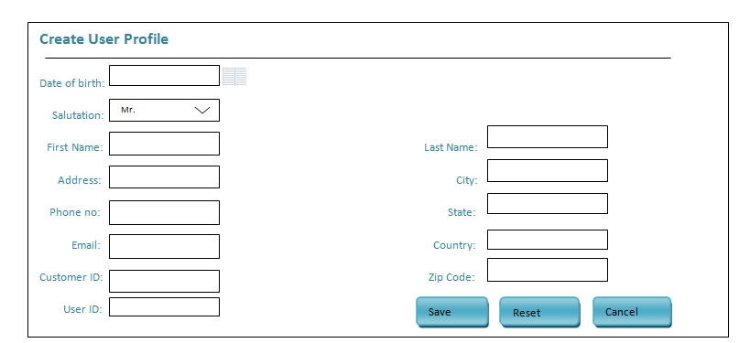

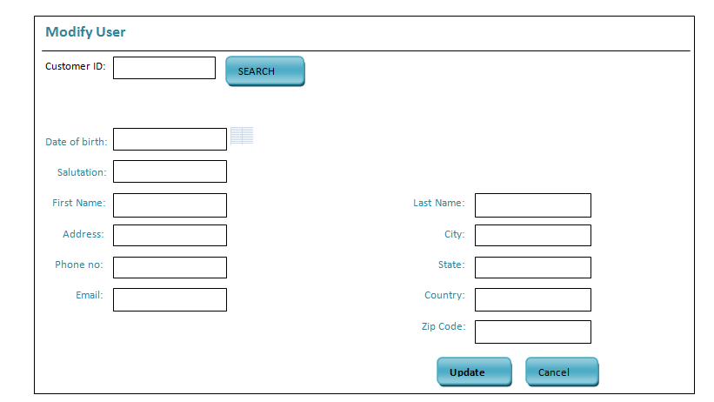

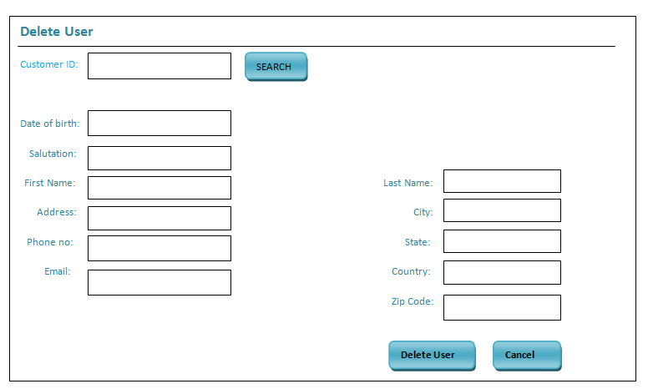

3.4 How the user interacts with the system.

* The user can register a customer into the internet banking system. When the customer details are submitted, the system automatically creates customer profile and sends the login details to the customer through email.

**High Level Design (object oriented analysis)**

* This chapter presents the object oriented view of the system, analysis of the high level design and describes the objects needed to implement the system. Each one of these objects is described and documented, and a data dictionary providing details of each object is provided.

4.1 Data Dictionary

Table name: LOGIN

This table is used to store login details.

|  |  |  |  |
| --- | --- | --- | --- |
| Field name | Data type | Length | Nullable |
| User ID | VARCHAR | 15 | No |
| Password | VARCHAR | 25 | NO |

Table Name: USER PROFILE

This table is used to store customer details.

|  |  |  |  |
| --- | --- | --- | --- |
| Field name | Data type | Length | Nullable |
| First name | VARCHAR | 25 | NO |
| Last name | VARCHAR | 25 | NO |
| Date of birth | DATE |  | NO |
| Salutation | VARCHAR | 8 | NO |
| Address | VARCHAR | 25 | NO |
| Phone | VARCHAR | 15 | NO |
| Email | VARCHAR | 25 | NO |
| Customer ID | VARCHAR | 8 | NO |
| User ID | VARCHAR | 8 | NO |
| City | VARCHAR | 25 | NO |
| county | VARCHAR | 25 | NO |

Table name: TRANSACTION

This table is used to store the transaction details.

|  |  |  |  |
| --- | --- | --- | --- |
| Field name | Data type | Length | Nullable |
| Posting date and time | Date and time |  | NO |
| Amount | VARCHAR |  | NO |
| Book balance | VARCHAR |  | NO |
| Narrative | VARCHAR | INT | NO |
| Account number | VARCHAR | 14 | NO |